Page Number Wizard

Table of Contents
.How to use?
.How it works?

How to Use:

.First Select the option below:



.A new page will open and In the top of the page, select Insert and then “Page Number”

How it Works?:

.Use the page number wizard to add the page numbers and select their position, alignment and style

.Page Number Position: Select between Top of the Page, Bottom of the Page and Center

.Page Number Alignment: Select between Center, Left, Right

.Page Number Style: Choose between more than 10 different styles.

.Include Page Total: Shows the total amount of Pages

.Mirror even pages: Keeps the same number style in all pages
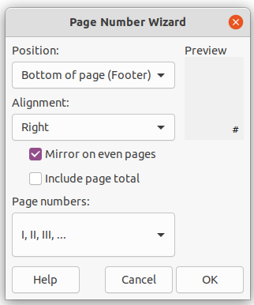

Topics that you may be intersted:

.Page numbers

